SIMATS ENGINEERING
Department of Artificial Intelligence and Data Science
SOFTWARE ENGINEERING
Case Study Analysis Report
AI-Powered Smart Aquifer Monitoring and Groundwater Conservation Platform
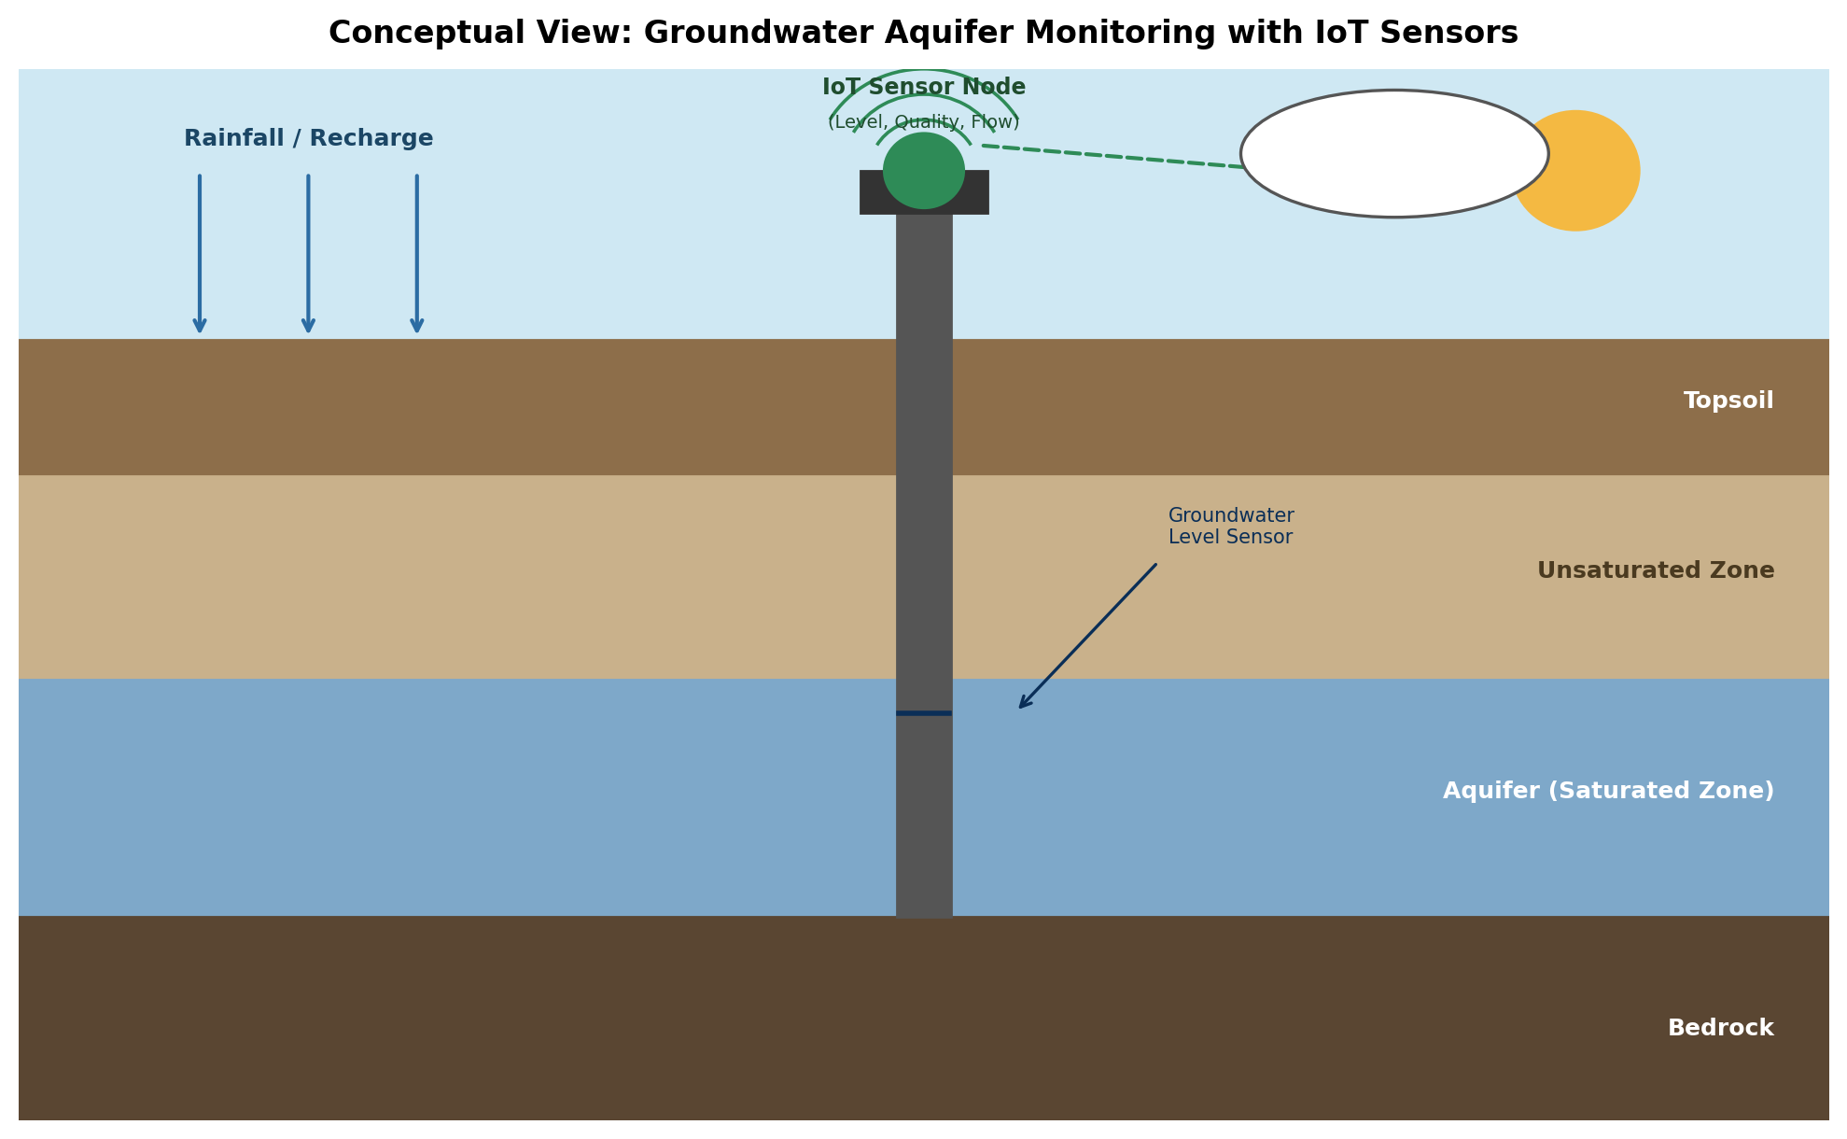

Field | Details
Submitted By | Y. Rishitha Reddy
Register No. | 192424233
Department | Artificial Intelligence and Data Science
Subject | Software Engineering
Faculty | Dr. Latha R.
College | SIMATS Engineering
Academic Year | 2024 – 2028

Table of Contents
1. Understanding the Problem Statement 3
2. Key Stakeholders and Challenges 4
3. Analysis of the Current Approach 5
4. Proposed Software Solution 6
5. Justification of the Chosen Methodology 8
6. Expected Outcomes, Risks, and Future Enhancements 9

1. Understanding the Problem Statement

1.1 Problem Explanation
Groundwater is one of the most critical natural resources supporting agriculture, industry, and domestic life, yet it is being extracted at a rate that far exceeds natural recharge in many regions. Traditional groundwater monitoring relies on periodic manual measurements taken from a limited number of observation wells, which means that decision-makers often work with outdated or incomplete data. This case study addresses the design of an AI-Powered Smart Aquifer Monitoring and Groundwater Conservation Platform — a software system that combines Internet of Things (IoT) sensors, Geographic Information System (GIS) mapping, remote sensing, and Artificial Intelligence to continuously observe groundwater levels, rainfall, soil moisture, and extraction rates, and to convert this raw data into actionable predictions and conservation recommendations.

1.2 Objectives of the Proposed System
- Continuously monitor groundwater levels across multiple locations in real time.
- Predict future groundwater availability using historical and live sensor data.
- Analyze rainfall and recharge patterns to understand replenishment trends.
- Detect excessive or illegal groundwater extraction at an early stage.
- Recommend context-specific conservation strategies to farmers and authorities.
- Generate groundwater analytics dashboards for quick, informed decision-making.
- Support sustainable water management practices across the region.
- Improve long-term environmental planning through data-driven insight.

1.3 Scope of the Problem
The scope of this project covers the design of a software platform capable of ingesting data from groundwater level sensors, rain gauges, soil moisture probes, and satellite/GIS feeds; processing this data through an AI/ML analytics engine; and presenting results through dashboards accessible to farmers, water boards, environmental agencies, and policymakers. The scope includes data acquisition, storage, prediction, visualization, and alerting, but excludes the physical manufacturing of sensor hardware, which is treated as a third-party, integration-only component. The system is intended to be scalable from a single district pilot to a state-wide or national deployment.

2. Key Stakeholders and Challenges

2.1 Stakeholder Identification and Responsibilities
Stakeholder | Role / Responsibility | Key Challenge
Farmers / Agricultural Users | Primary consumers of groundwater; use the platform to plan irrigation and receive conservation alerts. | Limited digital literacy; dependency on continuous extraction for livelihood.
Government Water Boards / Regulators | Monitor regional groundwater health, enforce extraction limits, and plan policy. | Fragmented data from multiple departments; delayed enforcement.
Environmental Researchers / Scientists | Analyze long-term trends, validate AI predictions, and study recharge behavior. | Need for high-quality, granular, and continuous data for accurate modelling.
Industries (Agro-based, Manufacturing) | Large-scale extractors who must comply with sustainable usage norms. | Balancing production needs with conservation mandates.
Local Communities / Households | Depend on groundwater for domestic consumption; affected by depletion and quality issues. | Limited awareness of long-term depletion risk; lack of direct monitoring access.
System Administrators / IT Team | Maintain platform uptime, sensor connectivity, and data security. | Handling large-scale IoT device management and cybersecurity threats.

2.2 Major Challenges Faced by Stakeholders
- Lack of real-time, continuous groundwater data leads to reactive rather than proactive decision-making.
- Poor coordination between multiple government departments managing water resources.
- Difficulty in detecting illegal or excessive extraction, particularly in rural and remote areas.
- Low awareness among farmers and households about sustainable groundwater usage practices.
- Climate variability (erratic rainfall) makes recharge prediction difficult without AI-based modelling.

3. Analysis of the Current Approach

3.1 Description of the Existing Process
Groundwater monitoring today is largely carried out through a network of manually read observation wells (piezometers) maintained by central and state groundwater boards. Field officers visit wells at scheduled intervals, record water levels using measuring tapes or basic instruments, and submit this data for compilation into periodic bulletins. Rainfall and recharge estimates are often derived from separate meteorological datasets that are not tightly integrated with groundwater records. Extraction volumes, particularly from agricultural borewells, are frequently self-reported or estimated rather than metered.

3.2 Strengths and Limitations
Aspect | Current Practice | Limitation / Gap
Data Collection | Manual measurement using observation wells at fixed intervals (often monthly or quarterly). | Sparse network of wells; infrequent readings miss short-term fluctuations.
Data Processing | Central agencies compile readings manually into spreadsheets or static reports. | Time lag between data collection and availability of insights; error-prone.
Prediction Capability | Little to no predictive modelling; decisions rely on historical averages. | Cannot anticipate sudden depletion or extreme weather impact.
Stakeholder Access | Reports published periodically by government bodies (annual/quarterly bulletins). | Farmers and local communities rarely have direct or timely access to data.
Extraction Monitoring | Self-reported extraction volumes or occasional physical inspection. | Under-reporting and lack of enforcement mechanisms.

3.3 Gaps That Need to Be Addressed
The existing approach suffers from low temporal resolution (infrequent readings), poor integration across data sources (rainfall, extraction, and levels are tracked separately), an absence of predictive analytics, and limited real-time accessibility for the very stakeholders who need it most — farmers and local water users. These gaps directly motivate the design of an integrated, AI-driven, sensor-based platform proposed in this report.

4. Proposed Software Solution

4.1 System Overview
The proposed solution is a layered, cloud-based platform that acquires data from distributed IoT sensors and satellite/GIS feeds, processes it through an AI/ML analytics engine, and delivers insights through role-based dashboards. The architecture is designed so that each layer can evolve independently, supporting long-term scalability and easy integration of new sensor types or analytical models.
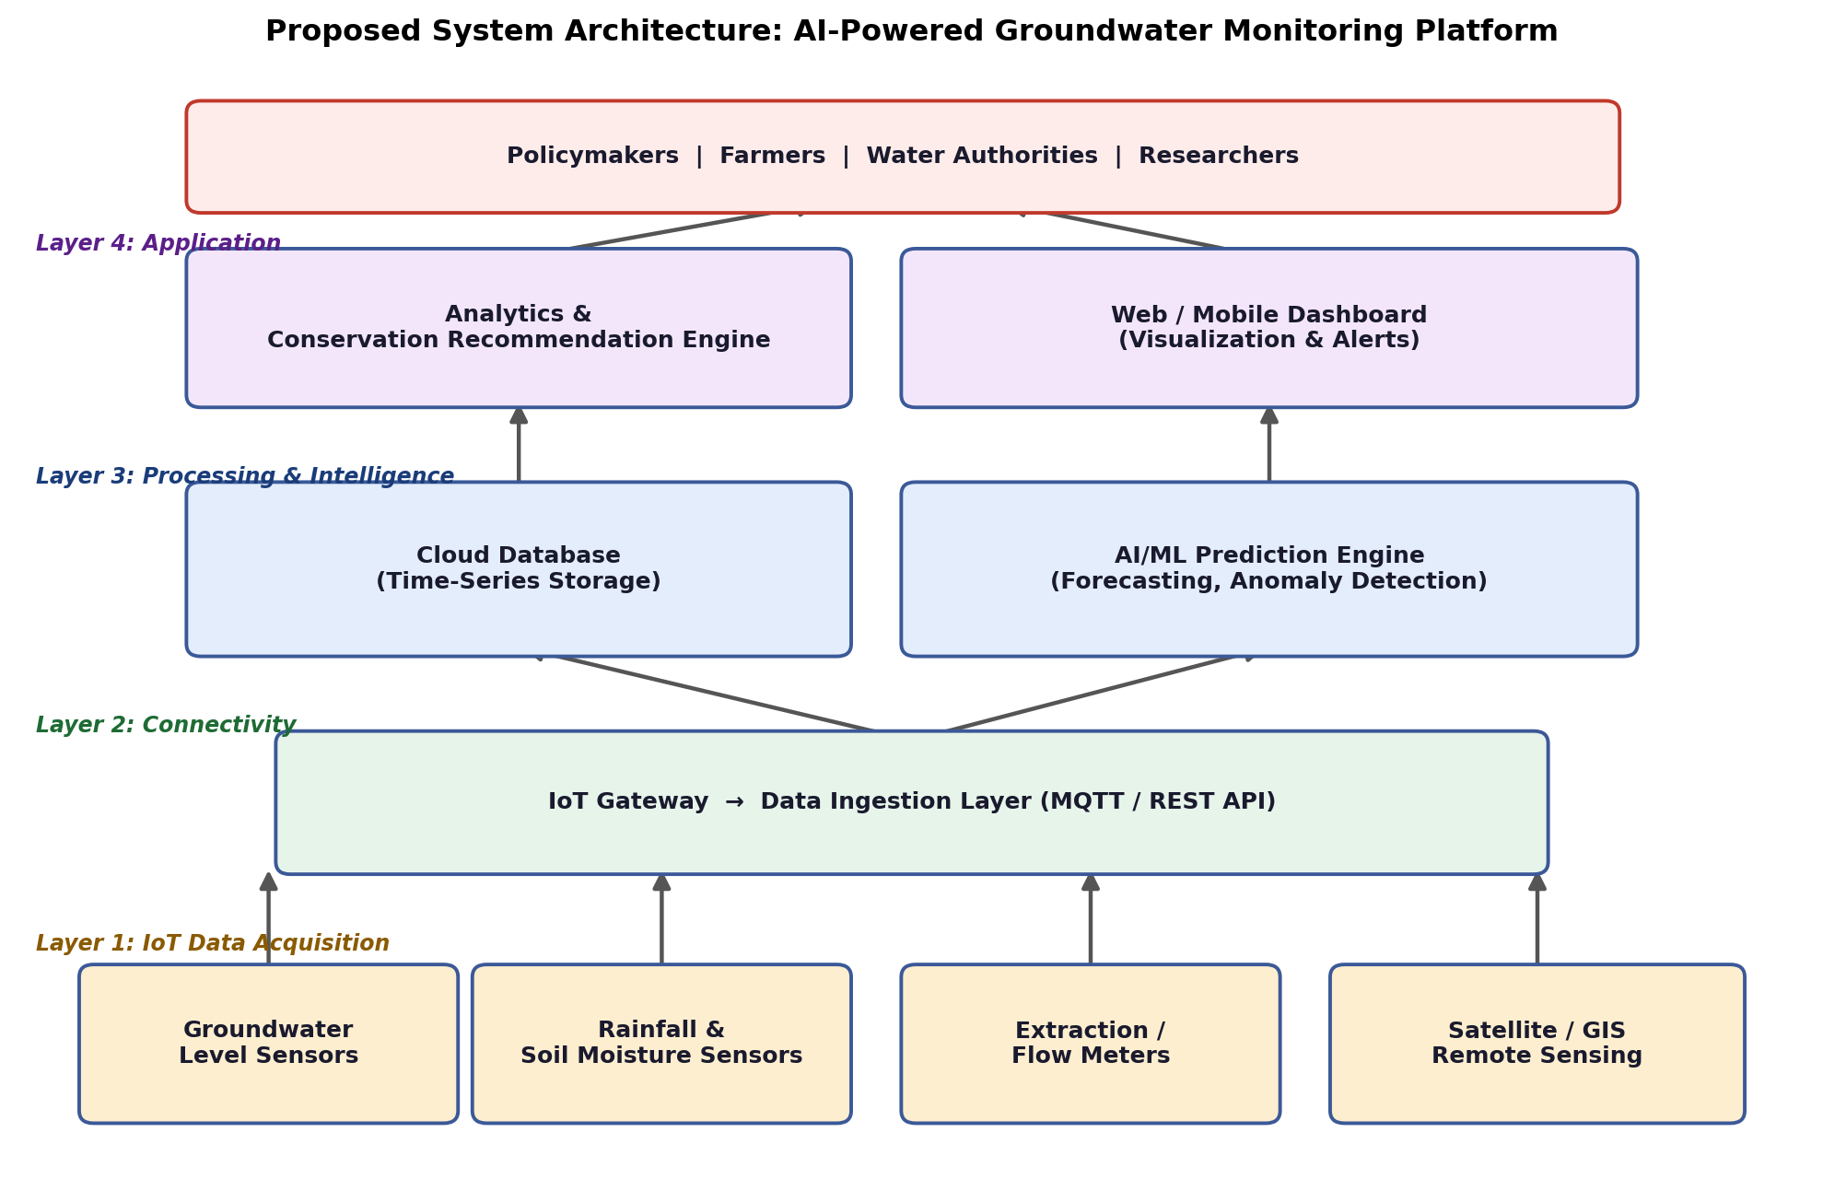
Figure 1: Proposed layered system architecture of the groundwater monitoring platform.

4.2 Major Functional Modules
- Data Acquisition Module — interfaces with groundwater, rainfall, soil moisture, and extraction sensors, plus satellite/GIS feeds.
- Data Ingestion & Storage Module — collects streaming data via IoT gateways and stores it in a scalable time-series database.
- AI/ML Prediction Module — forecasts groundwater availability and detects anomalies such as sudden depletion or illegal extraction.
- Conservation Recommendation Module — converts predictions into practical, localized conservation guidance.
- Visualization & Dashboard Module — presents maps, trend charts, and alerts to each stakeholder group.
- Policy & Reporting Module — allows regulators to configure thresholds and generate compliance reports.

4.3 Functional Requirements
ID | Requirement
FR-01 | Continuously collect groundwater level, rainfall, and soil moisture data from IoT sensors.
FR-02 | Store historical and real-time data in a scalable time-series database.
FR-03 | Run AI/ML models to forecast groundwater availability for the next 7/30/90 days.
FR-04 | Detect anomalies indicating excessive or unauthorized extraction and trigger alerts.
FR-05 | Generate conservation recommendations tailored to region, crop type, and season.
FR-06 | Provide a dashboard with maps, charts, and reports for different stakeholder roles.
FR-07 | Allow policymakers to define extraction thresholds and receive regulatory reports.

4.4 Non-Functional Requirements
Quality Attribute | Requirement
Performance | The system shall process and visualize sensor data within 5 seconds of ingestion.
Scalability | The platform shall support scaling from hundreds to millions of sensor nodes.
Reliability | The system shall maintain 99.5% uptime with automatic failover for critical services.
Security | All data transmissions shall be encrypted; role-based access control shall protect dashboards.
Usability | Dashboards shall be accessible to non-technical users such as farmers through simple visuals.
Maintainability | The system shall use modular services so components can be updated independently.

4.5 Application of Software Engineering Principles
- Modularity: Each function (data acquisition, prediction, recommendation, dashboard) is built as an independent module/microservice, allowing isolated development, testing, and deployment.
- Scalability: The cloud-based architecture and time-series database allow the platform to expand from a single district to a national network without redesign.
- Maintainability: Clear separation of concerns and documented APIs allow developers to update AI models or add new sensor types with minimal disruption to other modules.
- Reliability: Redundant data pipelines and automated failover ensure the platform continues operating even if individual sensors or servers fail.
- Usability: Role-specific, visually intuitive dashboards ensure that farmers, researchers, and policymakers can each interpret data relevant to their needs.
- Security: Encrypted data transmission, authentication, and role-based access control protect sensitive groundwater and extraction data from misuse.

5. Justification of the Chosen Methodology

5.1 Selected SDLC Model: Agile
The Agile software development model has been selected for the design and development of the AI-Powered Groundwater Monitoring Platform. Agile organizes development into short, iterative sprints, each delivering a working increment of the system that can be reviewed and refined with stakeholder feedback.
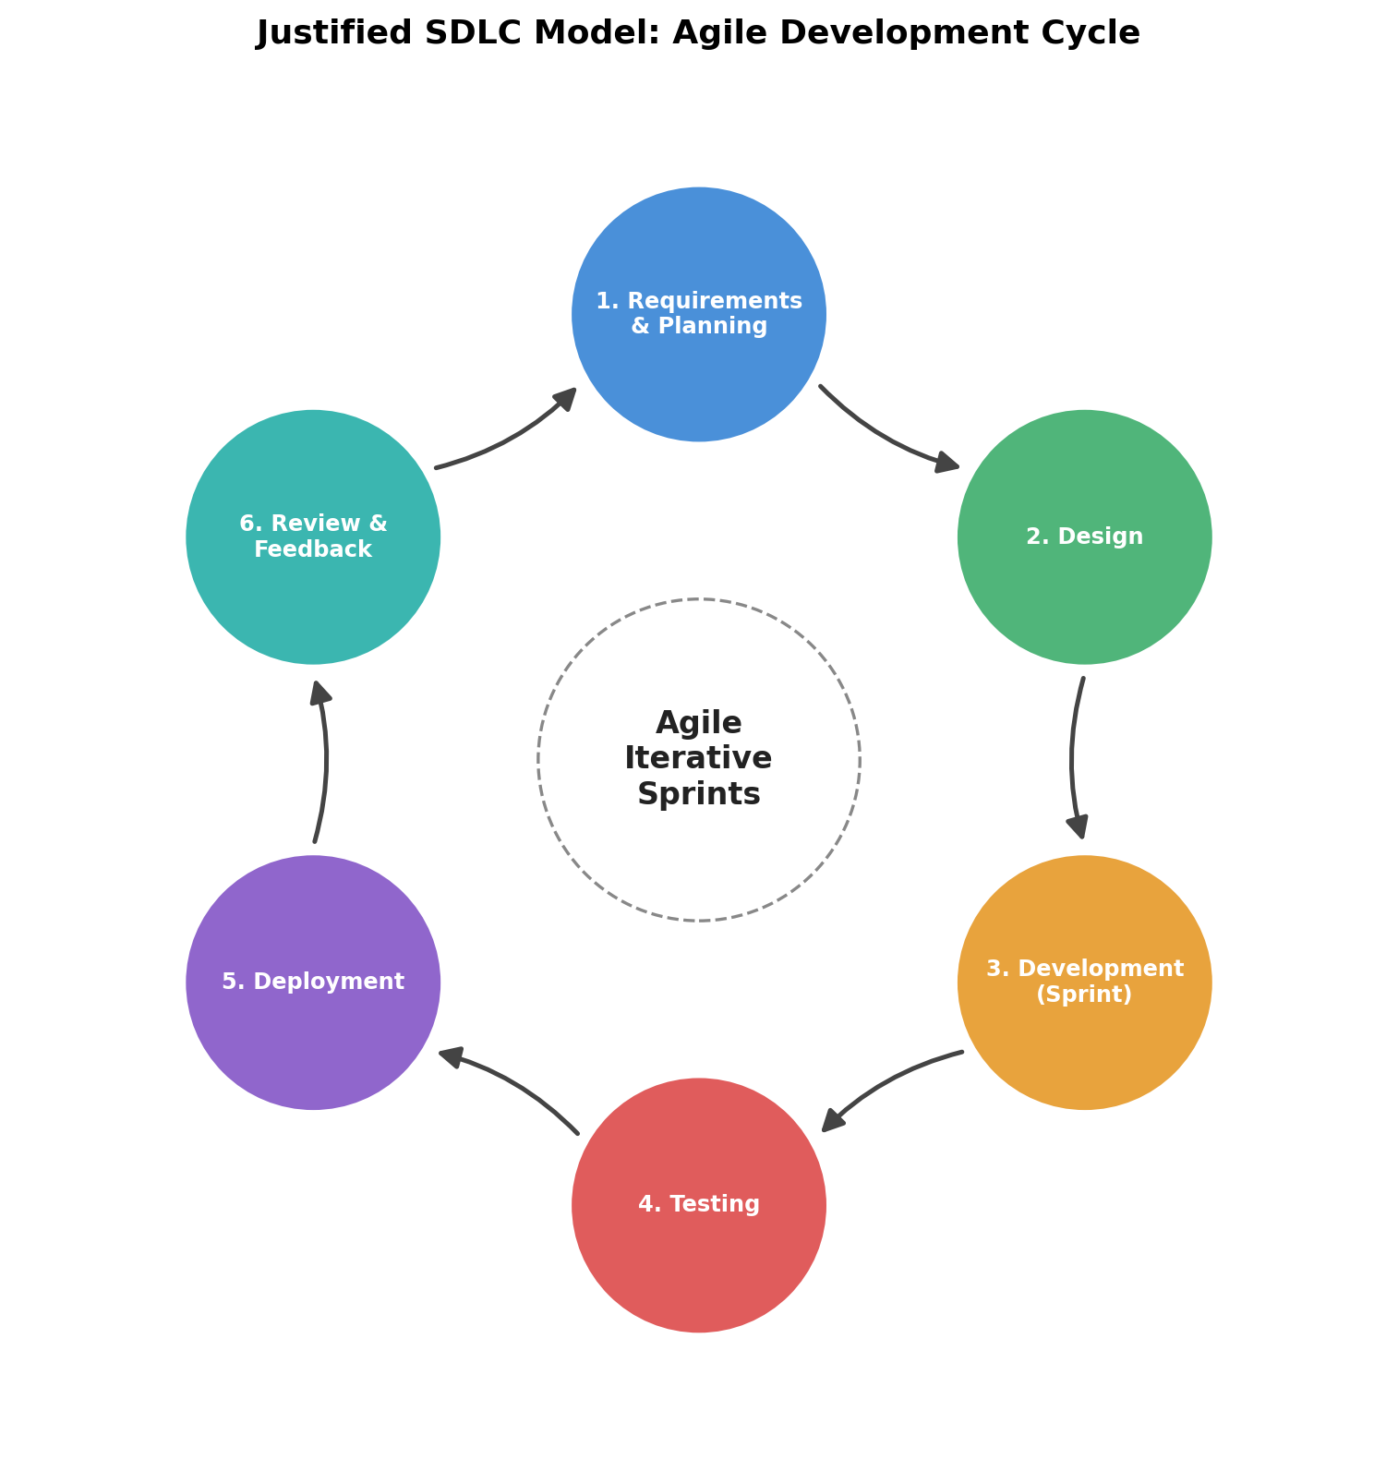
Figure 2: Agile iterative development cycle applied to the proposed platform.

5.2 Justification for Selecting Agile
- Evolving Requirements: Groundwater monitoring needs (new sensor types, additional regions, new regulatory rules) evolve over time; Agile accommodates changing requirements between sprints.
- Stakeholder Involvement: Regular sprint reviews allow farmers, researchers, and policymakers to give feedback early, ensuring the dashboards and recommendations remain practical and usable.
- Incremental Delivery: Core modules such as data ingestion and basic dashboards can be delivered first, with AI prediction and advanced analytics added in later sprints.
- Risk Reduction: Continuous testing within each sprint helps identify integration issues between IoT hardware and the software platform early, before they compound.
- AI/ML Compatibility: Machine learning models require iterative refinement as more data becomes available; Agile's cyclical structure naturally supports retraining and improving prediction accuracy over successive releases.

5.3 Support for Successful Development and Maintenance
By structuring development into sprints with regular retrospectives, the Agile model ensures that the platform can be continuously improved after deployment — for example, by incorporating new AI models, onboarding additional sensor networks, or refining conservation recommendations based on field results. This makes Agile well suited not only for initial development but also for the long-term maintenance and evolution of the platform.

6. Expected Outcomes, Risks, and Future Enhancements

6.1 Expected Benefits
- Improved groundwater conservation through timely, data-driven interventions.
- Reduced groundwater depletion via early detection of excessive extraction.
- Better long-term water resource planning for government and industry.
- Increased overall sustainability of agricultural and domestic water use.
- Enhanced environmental protection through continuous ecosystem monitoring.
- Data-driven policy decisions supported by accurate, real-time analytics.
- Improved agricultural water availability through optimized irrigation guidance.
- Better community water security, particularly in drought-prone regions.

6.2 How the Solution Addresses Identified Challenges
The proposed platform directly resolves the gaps identified in the current approach: continuous IoT sensing replaces infrequent manual readings, AI-based forecasting replaces static historical averages, and role-based dashboards give every stakeholder — from farmers to policymakers — direct, real-time access to relevant insights, closing the communication gap present in the existing system.

6.3 Potential Risks and Implementation Challenges
- High initial cost of deploying IoT sensor networks across large or remote geographic areas.
- Dependence on consistent internet/network connectivity in rural regions.
- Data privacy and security concerns around sensitive groundwater and extraction records.
- Need for accurate calibration and maintenance of sensor hardware over time.
- Resistance to adoption among stakeholders unfamiliar with digital platforms.

6.4 Future Enhancements
- Integration with satellite-based remote sensing for wider geographic coverage at lower hardware cost.
- Mobile application with offline support for use in low-connectivity rural areas.
- Blockchain-based extraction logging to improve transparency and prevent tampering.
- Integration with crop-advisory systems to jointly optimize irrigation and groundwater use.
- Expansion of AI models to include climate change scenario planning for long-term recharge forecasting.

6.5 Conclusion
The AI-Powered Smart Aquifer Monitoring and Groundwater Conservation Platform demonstrates how IoT, AI, and sound software engineering principles can be combined to address a pressing environmental challenge. By replacing fragmented, manual monitoring with a modular, scalable, and secure software system developed under an Agile methodology, the platform offers a practical, feasible path toward sustainable groundwater management.

